**Week 7 - Representational State Transfer (REST)**

Q 1: how can you tell the request was processed successfully?

ANS: We can verify the response and confirm that if the request was successful. Like, OK 200 response means the request was successful.

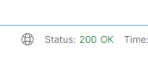

Figure : API response

Q 2: Explain the purpose of the “_links” element at the end of the JSON object received.

ANS: This _link element contains the other relevant URL of other resource in API.